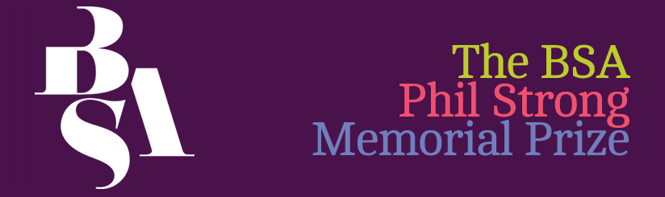

Application for the Phil Strong Memorial Prize

This form should be completed and returned to the BSA office by no later than 12pm on Friday, 17th of July 2026 to: enquiries@britsoc.org.uk or post to: Phil Strong Memorial Prize, The British Sociological Association, Chancery Court, Belmont Business Park, Belmont, DURHAM, DH1 1TW
For more details, please go to: http://www.britsoc.co.uk/medsoc/PhilStrong.htm

Applications will be judged anonymously against the following criteria:
- Clarity: Is there a clear description of how the prize will be used?
- Relevance to Medical Sociology: How closely does the research align with the core concerns and themes of medical sociology as a field of study?
- Impact: is the impact of the research outlined? This could relate to impact on the applicant, on their study, on the field of study, on key communities etc.
- Feasibility: is there a clear description of how the applicant will increase the success of the activities outlined.
[Detachable Section - For Administrative Use Only]
[Completed by administrative staff] | Application number:
Applicant details
Name:
Institution:
Address:
E-mail: Contact number:
BSA membership number:
Degree registered for:
Date registered:
Expected date of completion:
Supervisor details
Name:
E-mail:
Institution and institutional account through which the prize would be administered:
Signatures
Applicant signature:

Date:
I confirm that the details in this application are correct
Supervisor’s signature:

Date:

[Detachable Section – Application To Be Shared With The Early-Careers Representatives Of The Medical Sociology Committee]
[Completed by administrative staff] | Application number:
Study details
Study title:

Summary of research, please provide an outline of your study, including background, aims and objectives, methods and any finding to date, max 400 words:
Summary of research:

Prize Details
Proposed use of prize, please provide details of the activities to be supported and timetable, see note below, max 300 words:

Costs, please provide an itemised breakdown of the likely costs and total costs, including an explanation of the likely costs, max 100 words:

Please provide a brief justification of your likely costs (100 words):
Outcomes of prize, please provide a statement of how:
- the prize would contribute to the field of medical sociology;
- the impact of the prize (this can be on yourself as a researcher, on your project, on key communities, on the discipline etc.), max 500 words:

NOTE

The Phil Strong Prize Money may not be used for:
- Funding living expenses (e.g. rent);
- The material production of a thesis (e.g. photocopying and binding) (the BSA has a fund to which students can apply for this –http://www.britsoc.co.uk/students/SupportFund.htm);
- Courses which should be offered by the Department/Unit as part of normal provision for postgraduate or undergraduate students (e.g. standard courses in research methods);
- Return fares for an overseas student, registered in Britain, to return home. Exceptions may be made if there is strong evidence of how this would advance the study;
- Materials and equipment such as books, computers (including access to the internet) and tape-recorders which should properly be supplied by the sponsoring institution; and
- Any purpose which is unlawful.
- Printing costs
- Funds may not be used to attend MedSoc in the year that they are awarded as the winner will only be announced at that year’s conference. Therefore, the funds will not be released until after MedSoc. However, they could be used for the following year.

