DRAFT

BRITISH SOCIOLOGICAL ASSOCIATION MEDICAL SOCIOLOGY GROUP
Annual General Meeting

Thursday 13th September 2023, 12:45 – 13:45
Room G22, Jubilee Building, University of Sussex

Thirty members of the BSA Medical Sociology Group attended the meeting. It was chaired by co-convenor Gareth Thomas. Elaine Forester was responsible for minute taking.

- Gareth thanked everyone for taking time out of the conference schedule to come along to the AGM and ran through the agenda items in order. It was noted that the meeting was being recorded for minute-taking purposes only.

- Introduction and Updates
MedSoc Committee 2023 are confirmed as below. This is the largest the committee has been for a while.
Amelia Talbot | Katie Coveney
Christopher Elsey | Kylie Baldwin (Mat Leave)
Gareth Thomas (Co-Convenor) | María Jesús Vega Salas
Hazel Marzetti | Rose Watson
Hilllary Collins | Simon Carter
Jo Hope (Co-Convenor) | Sonali Shah
Julia Swallow | Victoria Cluley

Currently there are 10 active regional groups and 4 Special Interest groups. Pease see below.
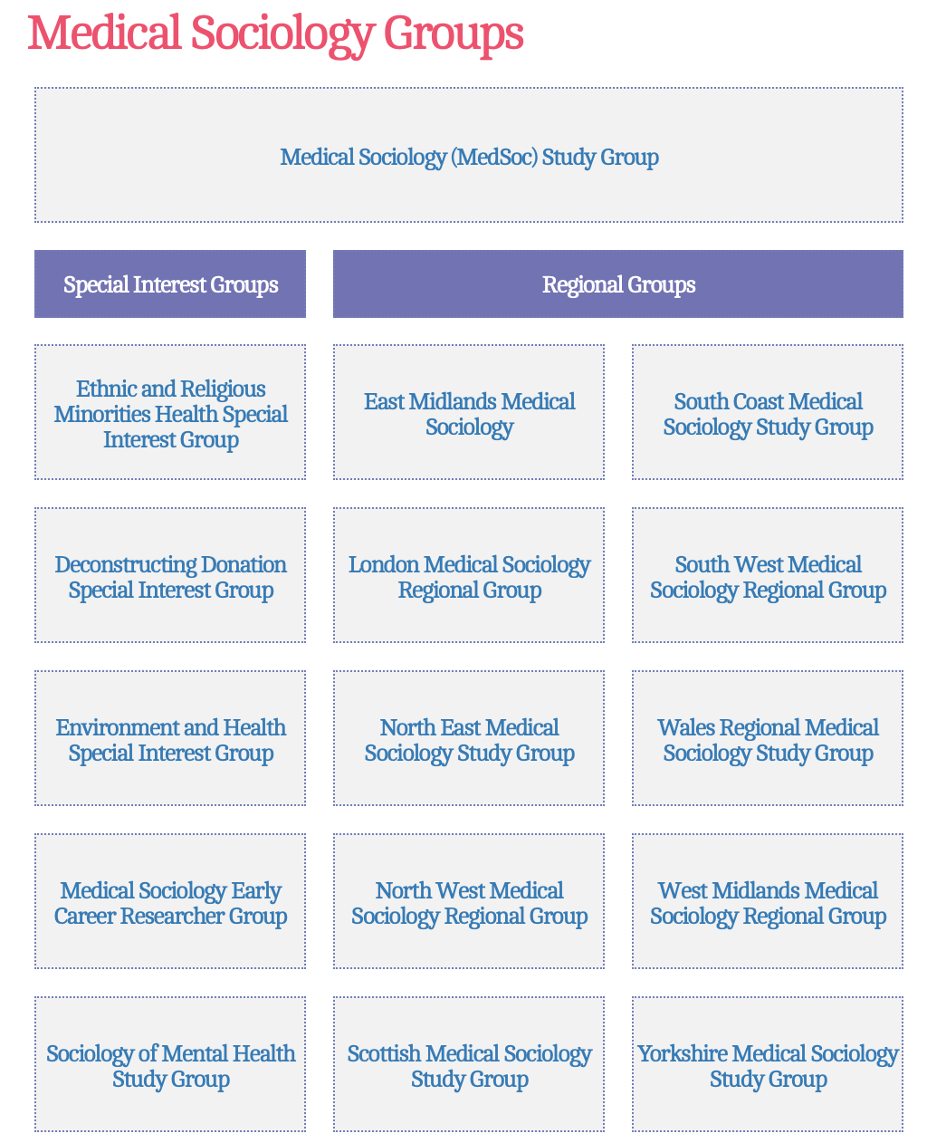

The Medicine Health and Illness Stream at this year’s BSA Annual conference (held at the University of Manchester, 12-14 April) had 53 abstracts submitted, with convenors Jen Remnant and Sarah Hoare responsible for blind reviewing and submitting the decisions to the BSA office.

36 were offered Oral presentations, 2 were offered Posters and 4 were placed on the reserve list. None were rejected and 11 submitters withdrew from the conference.

This year’s Medical Sociology conference held at the University of Sussex received 296 submissions. 162 were offered Oral presentations and 11 were offered Posters. There were 4 Special events and 2 Committee Events.

Please see below the delegate breakdown for this year’s conference.

274 Confirmed delegates
189 Booked for the full conference
45 Day delegates
24 Free places awarded (19 to Students and 5 to Unwaged delegates or delegates outside of academia)
- ommittee / BSA staff / invited speakers bookings
37 delegates registered for the ECR event which was held on Friday 8th September via Zoom

This year, as in previous years, we can truly call the Medical Sociology Conference ‘International’ with delegates from Australia, Belgium, Canada, Central Africa, Chile, China, Czechia, Denmark, Finland, Germany, Hong Kong, India, Ireland, Israel, Italy, Japan, Netherlands, New Zealand, Nigeria, Norway, Pakistan, South Africa and Sweden.

23 countries in total

Professor Alison Pilnick of the University of Nottingham was our opening plenary and Dr Ros Williams of the University of Sheffield will close the conference.

We have 6 Special Events in total (4 through the submission process and 2 committee events).

3 ‘Sandpit’ events were included in the programme on the first day covering 3 topics: Funding, Regional and Special Interest Group and ECR networking. Again the funding for these is provided by ‘Wellcome’ and will continue for the next 3 years.

Poster presentations were in conjunction with the FSHI drinks reception. Thanks to Willey for their continued support.

We offered the option to deliver presentations online using Zoom. 12 delegates chose this option and were charged £30.00 to attend the conference and deliver either a pre-recorded presentation or live on the day.

The Phil Strong and FSHI prizes will be announced at the conference dinner which will be held on Thursday 14th September at Brighton Place Pier in the Palm Court restaurant.

We welcome all feedback, which will help to shape future conferences. Please take a few minutes to complete the Survey at the end of the confrnce.

Many thanks to those leaving the Committee at the end of September 2023: Gareth Thomas (Co-Convenor) and Katie Coveney (Ordinary Member)

We welcome as new Co-Convenors from 1st October 2023 Hilllary Collins and Simon Carter

We have received 7 nominations for the 3 committee positions (2 ordinary members and 1 PGR)

For the ‘Ordinary’ Committee Members we have nominations from

Priya Davda (Bayswater Institute)
Lyndsey Kramer (Newcastle)
Jaime Garcia Iglesias (Edinburgh)

And for the PGR representation we have nominations from

Raquel Bosos Peres (Glasgow)
Katrine Callander (Kent)
Sarah C. Murphy (Sligo)
Andrew Hackett (Manchester)

The results of the voting will be announced in the usual way, via the conference notice board at the registration desk on Friday 15th September.

FSHI Book Prize 2023

This year we had 17 submissions, with 4 shortlisted:

Explaining Mental Illness: Sociological Perspectives (Baptiste Brossard [York] and Amy Chander [Edinburgh])

Reconsidering Patient Centred Care: Between Autonomy and Abandonment (Alison Pilnick [Nottingham])

Sickening: Anti-Black Racism and Health Disparities in the United States (Anne Pollock [KCL])

The Urban Brain: Mental Health in the Vital City (Nikolas Rose [UCL] and Des Fitzgerald [Cork])

The winner will be announced at the conference dinner By Tiago Moreira [Durham]

SHI Editorial Board Nominations

- 2 vacancies this year
- Nominees statements can be read on SHI website
- Online voting this year (circulated at conference)
- VOTING CLOSES ON 20 SEPTEMBER 2023
- Two applications for international board
- (discussed at SHI editorial board meeting on Wed)

Nominees:

Carrie Purcell, Open University
Chase M. Ledin, University of Edinburgh
Emily Jay Nicholls, KCL
Gavin Brookes, University of Nottingham
Ingrid Young, University of Edinburgh
Julia Frost, University of Exeter
Nina Fudge, Queen Mary, University of London
Peter Winter, University of Bristol
Sally SJ Brown, Leeds Beckett University
Sangeeta Chattoo, University of York
Tanisha Spratt, KCL

Foundation for the Sociology of Health & Illness report provided by Ellen Annandale and sent in advance of the AGM


Awards made 2022-2023
 | Awarded | Max. available
Mildred Blaxter postdoctoral fellowships | 5 | 5
Research Development Awards | 6 | 6
Workshops/symposia | 5 | 6
International conference attendance for PGRs/ECRs | 8 | 16

To find out about the awards please scan
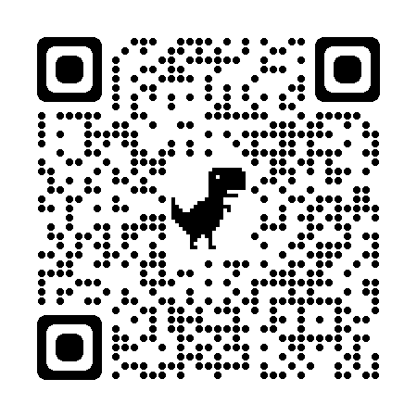

https://www.shifoundation.org.uk/

Next application deadline:
31 October 2023

The FSHI website has been substantially overhauled and everyone is encourage to take a look at the new format as believe it is much easier to navigate.


SHI Update

Thank you to everyone who has contributed to the journal as an author but particularly as a reviewer.
We would also like to thank Sarah David the long standing editorial manager who left the role in April this year and say welcome to Catherine Hyland who has taken over this role.

We would like to summarise the main point from the board meeting yesterday

- Going forward the editorial board is going to be open to international applicants, meaning anyone not based in the UK can also apply.
- Equally, the International Advisory Board previously only open to those based outside of the UK will also be open to UK members. Vacancies will be advertised in the coming months.
- There is going to be an appointment of a new editorial team in September 2024 as the current team have been in place for 5 of the 6 years term.

The ‘New Writers Prize’.
This is awarded to a new writer within SHI and someone who has receive their PHD in the last 5 years and who is name as a first authors on a paper.
This year winner is Josh Seim (Working diagnosis: The medical labour process and the classification of suffering)
And the highly commended award goes to Erik Børve Rasmussen, Lars E.F. Johannessen, Gethin Rees (Diagnosing by anticipation: Coordinating patient trajectories within and access social systems)
Cost of Living Blog (Simon Carter and Ewen Speed)

The blog has been operating for 11 years, publishing articles every other week with short breaks for Christmas and Easter. Over this period had just under 200,000 page views, 54% from the UK 15% from the USA and 11% from Europe, with the balance from the rest of the world. Over the last year had 19,000 page views of articles, the majority of which are written by the editorial collective, made up of 11 people? About 25% of the articles are from guest authors and have a policy of aiding authors to develop their work to a publication on the blog.

- Financial Report – presented by Elaine Forester, BSA Events Officer

Based on current forecast figures for this year’s conference at the University Sussex it is anticipated a surplus of just over £7k, this will be the first time a surplus has been made in the last few years. This means the closing balance at the end of the year will be approximately £71k and increase of £10K from close of business in 2022. This increase is partly due to the refund we received from Lancaster due to poor service provided.

Abstract submissions have increased to 296 which is a 31% increase from last year.
We offered the opportunity for delegates to present virtually using Zoom.12 presenters chose this option with some presentations being pre-recorded and others live presenting.

The Early Career Day was held on Friday 8 September with 37 delegates registered, this event was held on line.

Twenty four free places were offered this year, and all taken. We will continuing to utilise funds to support members of the group.

Cathy Pope who represents the BSA Board of trustees would like to hear any feedback from attendees regarding the funded places as she will represent you all at the next meeting

The five-year Wellcome grant funding has allowed MedSoc to introduce a ‘sandpit’ hybrid networking event.

This continued this year with 3 sessions included in the conference programme.

- Any other business

The next Annual General Meeting will be held during the Medical Sociology Conference on Thursday 12th September 2024.

