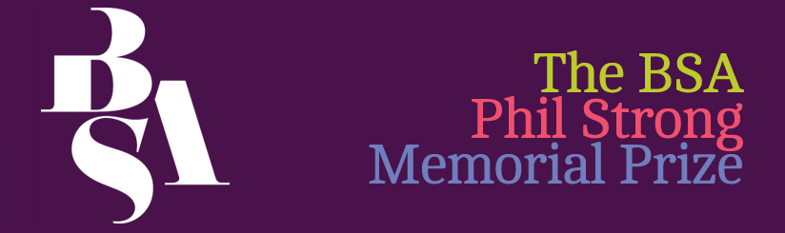

Application for the Phil Strong Memorial Prize

This form should be completed and returned to the BSA office by no later than Friday, 13 August 2021 to: enquiries@britsoc.org.uk or post to: Phil Strong Memorial Prize, The British Sociological Association, Chancery Court, Belmont Business Park, Belmont, DURHAM, DH1 1TW
For more details please go to: http://www.britsoc.co.uk/medsoc/PhilStrong.htm

Applicant details
Name:
Institution:
Address:

E-mail: Contact number:
BSA membership number:
Degree registered for:
Date registered:
Expected date of completion:
Supervisor details
Name:
E-mail:
Institution and institutional account through which the prize would be administered:

Sources of Income /funding
Funding – please provide details and amounts of any grant, bursaries or other awards already received or likely to be received within the following academic year:

Study details
Study title:

Summary of research, please provide an outline of your study, including background, aims and objectives, methods and any finding to date, max 500 words:

Prize Details
Proposed use of prize, please provide details of the activities to be supported and timetable, see note below:

Costs, please provide an itemised breakdown of the likely costs and total costs:

Outcomes of prize, please provide a brief statement of how the prize would enhance your study or sociological development, max 200 words:

Applicant signature:

date:
I confirm that the details in this application are correct

Supervisor’s signature:

date:
NOTE
The Phil Strong Prize Money may not be used for:
- The material production of a thesis (e.g. photocopying and binding) (the BSA has a fund to which students can apply for this –http://www.britsoc.co.uk/students/SupportFund.htm);
- Courses which should be offered by the Department/Unit as part of normal provision for postgraduate or undergraduate students (e.g. standard courses in research methods);
- Return fares for an overseas student, registered in Britain, to return home. Exceptions may be made if there is strong evidence of how this would advance the study;
- Materials and equipment such as books, computers (including access to the internet) and tape-recorders which should properly be supplied by the sponsoring institution; and
- Any purpose which is unlawful.

