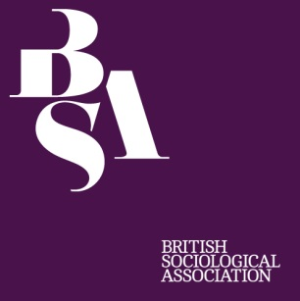

BSA National A-Level Sociology Competition 2016

Win yourself an iPad Mini and £250 for your school!

If you are aged 16-19 and would like to take part in a project which potentially can be included as part of your course work, you could win yourself a fabulous Apple iPad Mini as well as £250 for your school!

We invite you to conduct and submit research on the following: ‘what are the causes of social consensus and conflict in society today?’

What are you interested in? How does this relate to the above and use sociology to answer the question as part of a research project.
Entries are expected to refer to results obtained from their own primary method of research using a suitable sample. This could be an observation, an interview, a questionnaire based study. All research carried out for this competition has to abide the ethical guidelines of research, as stated at: https://www.britsoc.co.uk/equality-diversity/statement-of-ethical-practice/ . If you have any questions regarding the competition criteria, please contact: Claire Simmons – claire.simmons@britsoc.org.uk

Our National A-Level Competition, is open to anyone currently studying at A-level, A/S level, Scottish Higher Level or equivalent post-16 qualification in Sociology and we encourage you to be as creative as possible with your answers! The closing date for entries is Friday 9 December 2016 at 5pm.
How to enter:
Please email your entry with a completed entry form to or post it to: Claire Simmons, BSA, Bailey Suite, Palatine House, Belmont Business Park, Belmont, Durham DH1 1TW

Terms and conditions:
- Entries must be accompanied by confirmation from a Sociology teacher that it is the work of the pupil.
- Entries must be lone submissions (not joint).
- Reports must be around 2,000 words (excluding bibliography, figures, tables etc.)
- Filming your project as a presentation or podcast / YouTube entry (must not exceed 10 minutes).
- We reserve the right to check submitted works for plagiarism using online tools.
- Reference to other scholars (including teachers, books, articles and web sites) should be acknowledged.
- All work must be written or presented in the English language.
- The judges’ decision is final and we reserve the right to publish your entry with your permission.
----------------------------------------------------------------------------------------------------------------------------------------------Entry details

Title ________ Surname ___________________________ First name(s) __________________________
School / College name __________________________________________________________________
School / College address ________________________________________________________________
_____________________________________________________________ Post code ______________
School / College Year _______________ Email address ______________________________________
Tel. no. (Day)_______________________ Mobile No. ___________________ Date of birth __________
Entry format: Essay ( ) Podcast ( ) YouTube clip ( )
Teacher’s name ________________ Teacher’s Email address _____________________ Date ________

